Solace Debugger

While Solace is running, if the user hits <F5> (function key 5), the following debugger window will pop up. In the diagram below, each of the subwindows of the debugger is labeled, and will be described in more detail in subsequent sections. The five subwindows are
  - register subwindow
  - stack subwindow
  - disassembler subwindow
  - log subwindow
  - command subwindow
At the end there is a brief note on breakpoints.
The scrollbars that appear in three of the subwindows behave like normal Win32 scrollbars, except as noted. The thumb of a scrollbar can be dragged to reposition the window contents; clicking on the up/down arrows of a scrollbar scrolls the window by one line; clicking above or below the scrollbar thumb causes the window contents to scroll up or down by a screenful. If a given subwindow has input focus, achieved performing some mouse command (such as clicking) in the window, the keyboard interface to the scrollbar also works. That is, the up/down arrows scroll the window by one line; the page up/page down keys scroll the subwindow by one page.
Note that although the entire window can be resized, the only window divider than can be moved is the one between the disassembler subwindow and the log subwindow.
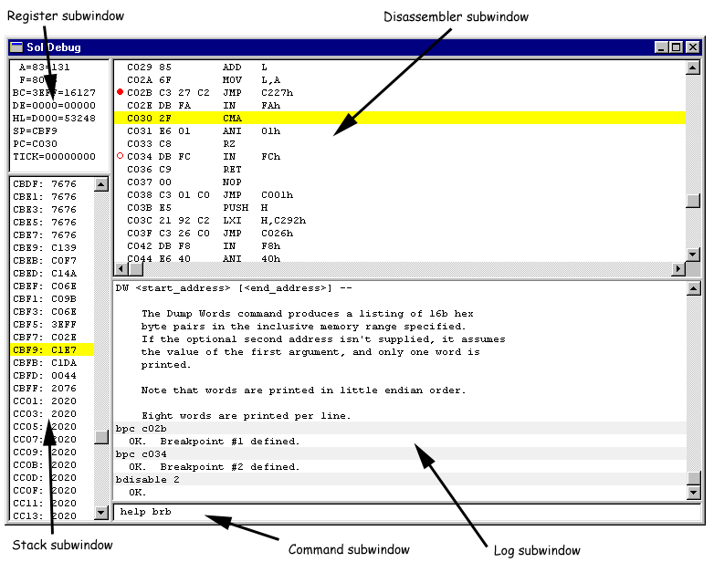

Register subwindow
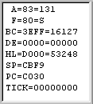 |  | The register subwindow shows the current state of all the 8080 registers any time the emulation is halted. It is automatically updated after each single step or other state change. This subwindow is grayed out while the emulator is running the 8080 processor.  The value for each register is given in two forms. The first form lists the register contents in hex (either 8b or 16b), the second form after the second '=' is the value in decimal. The flags register is somewhat different, in that the second form shows which flags are set mnemonically: S=sign, Z=zero, H=half carry, C=carry, P=parity.  Tick is the current emulated 8080 cycle count; it currently is not working.  This window is read-only. To modify the contents of a register, use the SET command via the command subwindow.

Stack subwindow
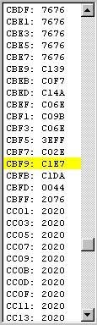 |  | The stack subwindow shows the region of memory surrounding the stack pointer, SP. The display shows 16-bit words, all even/odd aligned with the current SP value. The entry that corresponds to the top of stack (TOS) is shows highlighted in yellow. This subwindow is grayed out while the emulator is running the 8080 processor.  The region of memory being viewed can be manipulated in the usual ways via the scrollbar, or if the window has input focus, by the standard keyboard interface. As an extension of normal behavior, the HOME key can be used to scroll the window such that the TOS is visible.  Although this window automatically centers the display on the current TOS when the debugger is invoked, the window can be scrolled to any location in the 64K memory space. To make the scrolling fast, when the thumb is dragged, the window isn't updated; instead a small 4-digit hex number is shown, and the display is updated when the thumb is released.  The window is read-only. To modify the contents of the stack, or more generally any memory location, use the ENTER, EB, or EA commands via the command subwindow.

Disassembly subwindow
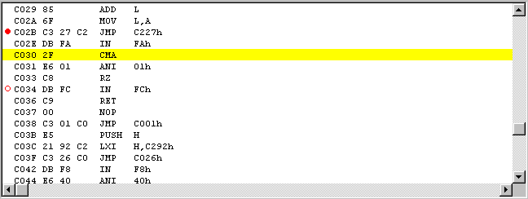
The disassembly subwindow is used to display the program in memory using standard Intel 8080 mnemonics. If the instruction corresponding to the current PC is in the window, it is displayed with yellow highlighting, as shown above. This subwindow is grayed out while the emulator is running the 8080 processor.
Using standard windows scrollbar behavior, the user can change the region being displayed in the window. As an extension of normal windows scrollbar behavior, if the window has input focus, hitting the HOME key causes the display to scroll such that the line containing the current PC is positioned in the window.
Because updating the display is slow, dragging the thumb on the vertical scrollbar doesn't immediately scroll the display. Instead, a four-digit hex display is shown of which area of memory will be displayed when the thumb is released.
Note that scrolling backwards or jumping to an arbitrary starting location is problematic. This is because 8080 instructions can be one, two, or three bytes long. For example, when scrolling back one line, going back one byte might be a valid one byte opcode, or it might be the immediate data of a two-byte or three-byte instruction. Solace uses a heuristic to try and get a reliable "sync"; it goes back 10 instructions or so and disassembles forward. If the address of interest falls in the middle of an instruction in the resulting stream, it is assumed that the immediately preceding instruction start is the true instruction boundary. Although it works is most cases, the heuristic isn't foolproof, so be warned that this may happen if the disassembly seems goofy.
Note that two of the instructions have a red circle in the left column. A solid red circle (at $C02B, above) means that there is an active breakpoint on that instruction. A hollow red circle (at $C034, above) means that there is a disabled breakpoint on that instruction.
Breakpoints can be entered, listed, and manipulated via the command line interface, but this window provides a few shortcuts as well.
- Holding down the CTRL key and left-clicking on a line causes a breakpoint to be set on that line. If there is already an active breakpoint on the line, it is disabled; if there is already a disabled breakpoint on that line, the breakpoint is killed (deleted).
- Double left clicking on a line causes a temporary breakpoint to be set on the line and 8080 execution is resumed until the line is reached or another breakpoint is encountered, whichever comes first.
- Right clicking on a line causes a pop-up menu to appear with a few choices; some choices will be grayed-out based on context:
  - Add breakpoint
  - Disable breakpoint
  - Enable breakpoint
  - Kill breakpoint
  - Run to PC
  - Home current PC
The integrated Solace 8080 debugger supports source code overlays. These are simply the .PRN files that are output by the standard CP/M ASM and MAC assemblers. Whenever a .ENT or .HEX file is loaded from the main menu, Solace looks in the same directory for a file with the same root name but with a .PRN suffix. If it is found, it is "autoloaded" as a source code overlay. Optionally, a user can manually load a source code overlay via the debugger command line interface via the "OVerlay" command. In either case, the OVerlay command has many forms which can be used to control how overlay information is managed and used.
Below appears three snippits of the disassembler window with different overlay modes enabled. In the "on" mode, whenever Solace needs to disassemble at a given instruction, it checks to see if there is a source code overlay matching that address. If there is a match, then the source code file is displayed. If there is no match, the line is just mechanically disassembled. In the "off" mode, it is as if there is no overlay in memory. In the "both" mode, if there is a source code overlay for a given address, it is displayed (but in gray) and the line is also mechanically disassembled.
In either "on" or "both" modes, the bytes of memory corresponding to the source line are compared against the actual memory contents. If they don't match, the source line is still printed, but it appears as red text instead of black.
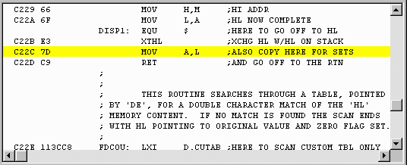
Above: "overlay on"
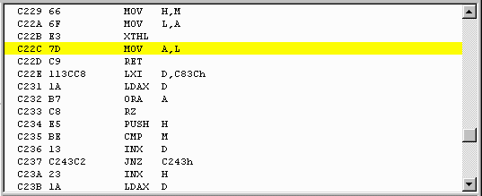
Above: "overlay off"
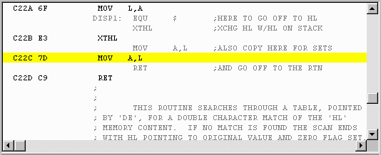
Above: "overlay both"

More than one overlay can be in memory at one time. If one address has a match in more than one overlay, the most recently loaded or refreshed overlay is the one shown. In the cause of autoloaded overlays (i.e., those loaded implictly as the result of loading a .hex or .ent file from the main menu), the overlay system can elect to dispose of an overlay if too little of the overlay is meaningful. Manually loaded overlays stay in memory until explicitly purged.
The overlay command takes many form so it is best to type "help overlay" in the debugger to get the rundown.

Log subwindow
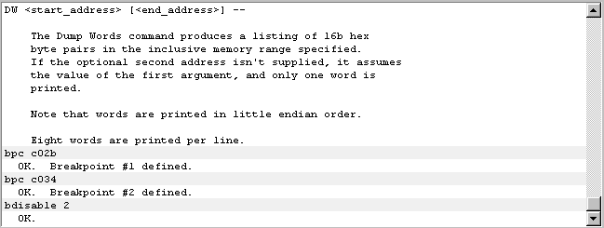
The log subwindow shows a history of commands that the user has typed in and the debugger responses. The user input is echoed with a grayed background to help distinguish commands from responses.
500 lines of history are maintained; lines older than that simply vanish. There is currently no way to log the output to a file, nor to copy a selection from the window.
The vertical scroll bar appears whenever there are enough lines in the command history to warrant it. The scrollbar responds to the typical scrollbar behavior: the window may be scrolled up/down a line/page at a time by clicking on the up/down arrows are above/below the thumb; the thumb can be dragged. If the log subwindow has input focus, which is achieved by clicking in the window or by manipulating the scrollbar, then the scrollbar responds to standard keyboard scrolling behavior. The up/down arrow keys move the display up/down one line; the up/down page keys scroll the display a page at a time. Typing the HOME key causes the window to scroll such that the last entry becomes visible.

Command subwindow
The command subwindow accepts debugger commands from the user; a command is interpreted when the ENTER key (carriage return) is hit.
50 lines of command history are maintained; commands older than this are simply discarded. The user can access older commands via the up/down arrows; up-arrow corresponds to moving to older commands. To prevent tediously scrolling past commands which have been repeated, the command history mechanism will show a given command only once when scrolling up or down through the command history.
Note that some of the mouse command shortcuts in the disassembler subwindow "stuff" phantom commands into the command subwindow to cause the specified actions to happen.
A brief rundown of the debugger commands can be had at any time in the debugger by typing
help
without any arguments. Here is a key to interpreting the following table of commands:
- <foo> means that foo isn't literal, just descriptive of what the argument is.
- Things in square brackets, like [foo], means it is an optional argument.
- Ellipses (...) means that there can be a number of subsequent arguments.
- Command names can be abbreviated in many cases; below the necessary part is shown in caps, while the optional part is in lower case and inside parentheses.
- Numeric arguments are hex by default, but this can be overridden to be decimal by starting the number with a "#" character.
- The command line is case insensitive except for the string arguments to the EA and LA commands.
Here, then, is the list of commands:
memory commands:
DB <start> [<end>] dump bytes
DW <start> [<end>] dump words
DA <start> [<end>] dump ascii
EB <start> aa bb ... enter bytes (also EN(ter))
EA <start> abcde... enter ascii
FILL <start> <end> <bb> fill block
LB <start> <end> aa bb ... locate bytes
LA <start> <end> abcde... locate ascii
MM <start> <end> <dest> move memory
CM <start> <end> <dest> compare memory
SM <start> <end> aa bb ... show matching bytes
DASM <start> [<end>] disassemble
LOAD <fname> load .ent or .hex binary file
SAVE <start> <end> <fname save binary to .ent file
SAVEH <start> <end> <fname> save binary to .hex file
execution commands:
RESET reset uP
N(ext) [<nnnn>] step over n ops
S(tep) [<nnnn>] step in n ops
EX(ecute) [<nnnn>] continue execution
C(ont) [<nnnn>] synonym for EX
SET <reg> <nnnn> modify register
INC(lude) <filename> perform a file of commands
breakpoint commands:
TO aaaa run to PC=aaaa
BP(c) aaaa break PC=aaaa
BR(b) aaaa [dd [mm]] break read byte addr=aaaa, data=dd, mask=mm
BRW aaaa [dddd [mmmm]] break read word addr=aaaa, data=dddd, mask=mmmm
BW(b) aaaa [dd [mm]] break write byte addr=aaaa, data=dd, mask=mm
BWW aaaa [dddd [mmmm]] break write word addr=aaaa, data=dddd, mask=mmmm
BI(n) aa [dd [mm]] break in port=aa, data=dd, mask=mm
BO(ut) aa [dd [mm]] break out port=aa, data=dd, mask=mm
BL(ist) [<nn>] breakpoint list all/nn
BD(isable) [<nn>] breakpoint disable all/nn
BE(nable) [<nn>] breakpoint enable all/nn
BK(ill) [<nn>] breakpoint remove all/nn
misc commands:
OV(erlay) [<file[.prn]>|<id>] [OFF|ON|BOTH|REFRESH|KILL] source code overlay
KEY <nn> force a keystroke
H(elp) [<cmd>] command summary
EXIT | X(it) close debugger
There is a detailed command description for each debugger command, accessed by typing
help <command>

Brief note on breakpoints
There are two types of breakpoints: PC breakpoints, and data breakpoints (read byte, read word, write byte, write word, in, and out). It should be noted that PC breakpoints are triggered before the instruction at the specified address is executed, while data breakpoints occur after the instruction that triggered the breakpoint is executed.

Back to Solace main page.
Last update: May 1, 2002

